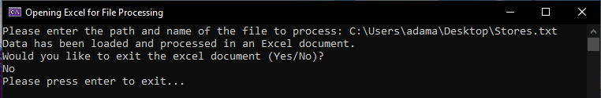^Shows program executing

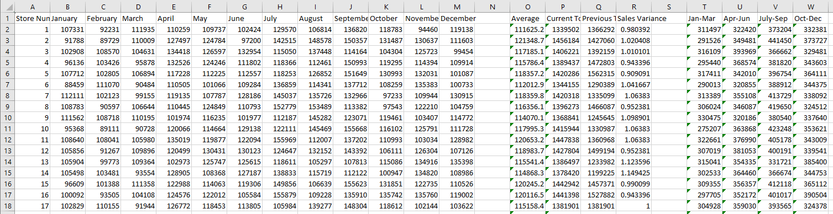

^Sample of data from Excel